TO LET BY INFORMAL TENDER

CORONATION PARK DEPOT, CLAREMONT ROAD, CROSBY L23 5RD

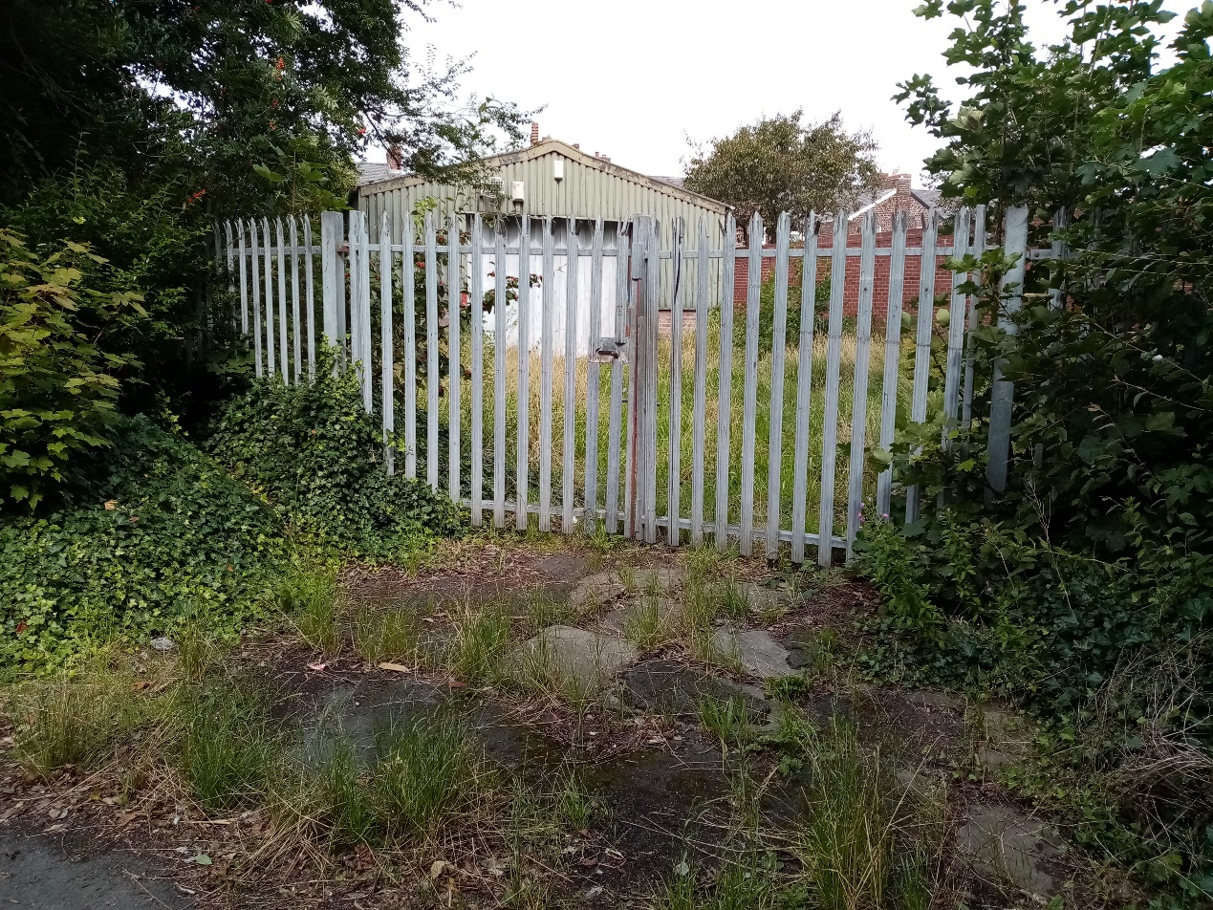

Property and Facilities Management
Second Floor Magdalen House
30 Trinity Road
Bootle
L20 3NJ
MISREPRESENTATION ACT 1967

Sefton Council, as Lessor, gives Notice that:

- These Particulars do not constitute any part of an offer or a contract.

- All statements contained in these Particulars as to the property are made without responsibility on the part of the Lessor.

- None of the statements contained in these Particulars as to the property are to be relied upon as statements or representations of fact.

- Any tenderer must satisfy himself/herself by inspection or otherwise as to the correctness of each of the statements contained in these Particulars.

- The Council does not make or give, nor has any person in the employment of the Council any authority to make or give any representation or warranty in relation to the property.

CONTENTS

- Introduction

- Location

3. Description

4. Accommodation

5. Proposals

6. Planning Advice

7. Tenure and Lease Terms

8. Terms of Tender

9. Costs

- Additional Information

- Services and Investigations

- Important Notes

- Form of Tender

APPENDICES

- Location Plan.

- Layout Plan.

3. Energy Performance Certificate.

DEPOT CORONATION PARK, CLAREMONT ROAD, CROSBY, LIVERPOOL. L23 5RD

1.0 Introduction

1.1 The Council Depot at Coronation Park is offered on a “contracted out” Lease, by way of informal tender. Proposals and rent offers are sought for a new Lease of the property.

1.2 The premises consist of one building and a fenced, gated and walled yard. The premises are no longer required for Council use and vacant possession will be provided prior to completion.

2.0 Location

2.1 The property is located within the boundaries of Coronation Park. The main park area is to the south and west of the site.

2.2 The property comprises one single storey industrial building accessed by a gated entrance off an access road from Claremont Road. A fenced, gated and walled storage yard surrounds the building.

2.3 The premises are not shared.

2.4 Pedestrian and vehicular access to the property is via the main entrance gates off an access road via Claremont Road.

2.5 A Location Plan can be found at Appendix 1.

3.0 Description

3.1 The property consists of the following:

Industrial Building
Fenced, gated and walled yard

3.2 The Floor/Layout Plan is included in Appendix 2.

3.3 Prospective Lessees should carry out their own inspection of the property.

3.4 All main services are believed to be available at the property.

3.5 An Energy Performance Certificate is included in Appendix 3. The EPC Rating is G.

- Accommodation

  - The Gross Internal Area (GIA) of the building is 91 square metres or 979.3 square feet.
The overall site area is 690 square metres or 7,427 square feet.

5.0 Proposals

5.1 Interested parties are invited to submit offers for a Lease of the property in accordance with the planning advice detailed later in these particulars (see clause 6.0.)

5.2 Prospective tenants shall be responsible for obtaining planning permission for their proposals for the property, if required, which shall be approved by the Council, as Landlord, in addition to its statutory role as Planning Authority.

5.3 Prospective tenants shall bear all the costs and expenses associated with their proposed use of the property.

5.4 As this is Council property, it is a requirement that prospective tenants use the Council’s Building Control Section for all applications and approvals connected with Building Control matters.

- Planning Advice

6.1 Coronation Park is a public open space and is located to the south and west of the premises.

6.2 The property is therefore suitable for a limited range of uses functionally linked and ancillary to previous operations. Suitable functionally linked and ancillary uses include workshops for vehicles, woodwork, metalwork, external and internal storage.

6.3 Due to the site’s designation as a ‘greenspace’, the Council is likely to restrict changes of use within any approved use and other changes of use, including those permitted by the Town and Country Planning (General Permitted Development) (England) Order 2015 (as amended (the GDPO) or the Use Classes Order.

6.4 The key issues are as follows: -

Open space, noise and amenity: The development must be sensitive to the continued and effective operation of Coronation Park to the south and west of the site.

Access and parking: Existing. Access off Claremont Road. On-site parking.

Main town centre uses: Uses defined as main town centre uses in the National Planning Policy Framework (see https://www.gov.uk/guidance/national-planning-policy-framework), e.g. retail, must meet the sequential test requirements set out in policy ED2 ‘Retail, leisure and other town centre uses’.

Minerals: Although the site is in a Minerals Safeguarding Area the limited scale of development would exempt it from the need to produce a minerals statement.

Other issues: Any external works or alterations, such as provision of any additional parking, servicing or access areas or alternations to doors and windows may be subject to an assessment of impacts on design, contamination, flood risk, ecology and other relevant issues.

Signage: Signage is permitted at the property to advertise the proposed business with the Consent of the Landlord, which will not be reasonably withheld.

6.5 Development must comply with the Sefton Local Plan (2017) (see https://www.sefton.gov.uk/localplan). Some of the key Local Plan policies are listed below:
- ED2 ‘‘Retail, leisure and other town centre uses’’
- IN1 ‘Infrastructure and developer contributions’
- EQ1 ‘Healthy Sefton’
- EQ2 ‘Design’
- EQ3 ‘Accessibility’
- EQ4 ‘Pollution and hazards’
- EQ5 ‘Air quality’
- EQ6 ‘Contaminated land’
- EQ8 ‘Managing flood risk and surface water’
- EQ11 ‘Advertisements’
- NH1 ‘Natural assets’
- NH2 ‘Nature’
- NH5 ‘Protection of open space and Countryside Recreation Areas’
- NH8 ‘Minerals’.

6.6 Supplementary Planning Documents (SPD) and other guidance may be relevant also (see https://www.sefton.gov.uk/spd), notably:
- Sustainable Travel and Development SPD (2018)
- Open Space SPD (2017)
- Nature Conservation SPD (2017)
Highways developers pack –see http://www.sefton.gov.uk/parking,-roads-travel/highway-development-and-design.aspx

6.7 It is strongly advised that pre-application advice is sought for any proposal on this site before submitting a planning application. A fee is charged for this service. See: http://www.sefton.gov.uk/planning-building-control/apply-for-planning-permission/how-to-make-a-planning-application.aspx.

7.0 Tenure and Lease Terms

7.1 The property is held freehold by Sefton Metropolitan Borough Council. The Council offers a Lease of the property based on the following terms and conditions: -

Landlord: | Sefton Metropolitan Borough Council, Magdalen House, 30 Trinity Road, Bootle, L20 3NJ.
Lessee: | Please provide full details in the Tender Form including Company Number and registered address or correspondence address if different
Property: | The Property shall be as shown on the attached plans in Appendices 1 and 2.
Term: | The parties shall enter into a Lease for a term of five years commencing from a date to be agreed. The Lease shall be contracted out of Sections 24 to 28 of the Landlord and Tenant Act 1954 relating to security of tenure.
Rent: | Rent offers are invited. The rent shall be payable quarterly in advance, exclusive of rates, VAT and all other outgoings.
Condition: | The Lessee shall take the property in its existing condition and carry out the works and any repairs at their own expense, to a standard in accordance with plans, drawings and specifications to the Council’s reasonable satisfaction.
Warranty: | The Landlord does not provide any warranty as to the fitness of the property or apparatus contained therein. It is the Lessee’s responsibility to ensure the property meets their requirements.
Service Charge: | The Lessee shall be responsible for a proportionate charge for the repair and maintenance of the access road leading to the property.
Repairs: | The Lessee shall be responsible for the repair and maintenance of the property, any open areas and boundary walls/gates to the Council’s reasonable satisfaction in accordance with a photographic Schedule of Condition to be agreed at the commencement of the Lease.
Decoration: | The Lessee shall paint the interior and exterior of the Property at least once during the term, in accordance with a colour scheme and specification to be approved by the Council as Landlord, such painting to be carried out to its reasonable satisfaction, if demanded.
Outgoings: | The electricity, gas, and water consumption at the Property shall be the responsibility of the Lessee and the Lessee shall bear any costs arising as a result of their occupation.  The Lessee shall be responsible for the installation and any costs incurred in connection with IT, telephones or internet in relation to their use of the Property.
Indemnity: | The Lessee shall indemnify the Landlord against all costs, claims damages etc arising out of the use and occupation of the property and shall provide evidence of such Third Party, Employers and Public Liability insurance cover on commencement and thereafter on demand.
Insurance: | The Lessee shall be responsible for insuring the Property for its reinstatement value against normal insured perils including for two years loss of rent and professional fees. The Lessee shall provide evidence of cover on commencement and thereafter on demand.
Use: | Subject to the receipt of any planning permission (if required) the Property shall be used for the purposes as set out in the Tender Form. The Landlord’s prior written consent, as Landlord and Planning Authority, will be required for any variation to the user.
Opening Hours: | The permitted opening hours shall be agreed between the parties or as per any planning permission required for the use.
Nuisance: | The Lessee shall ensure that no nuisance or annoyance is caused to neighbours and adjoining owners, tenants or occupiers.
Statutory Approvals: | The Lessee shall be responsible for obtaining the requisite Statutory Approvals in connection with the use and occupation of the Property and any works to be undertaken at the Property.
Compliance Certificates and Testing: | The Lessee shall be responsible for obtaining all certification relating to the Property, including electricity, heating, water, alarms, emergency lighting, Legionella testing, asbestos testing etc. The Lessee shall provide evidence of certification on demand.
Statutory Regulations: | The Lessee shall comply with all Licensing, Statutory Regulations, Acts, Environmental Legislation, Health and Safety Legislation, etc in connection with the use and occupation of the Property.
Cleaning: | The Lessee shall be responsible for the cleaning of the Property.
Open Areas: | The Lessee shall be responsible for keeping all open areas in a neat and tidy condition.
Waste: | The Lessee shall be responsible for the removal of any waste/refuse associated with its use of the Property.
Alienation: | The Lessee shall not be permitted to assign the whole of the property without the Landlord’s prior written consent such consent not to be unreasonably withheld or delayed. Assignment or subletting of part will not be permitted.
Alterations: | The Lessee shall be permitted to carry out non-structural internal alterations only. Structural or external alterations will not be permitted.
Inspection: | The Landlord shall be permitted to inspect the condition of the Property on service of reasonable notice and with immediate effect in case of an emergency.
Signage: | The Lessee shall not erect any signs, Notices or Advertisements on the Property without the Council’s prior written consent as Landlord and Planning Authority. Landlord’s consent shall not be unreasonably withheld or delayed.
Termination: | The Lessee shall yield up the Property at the end of the term in accordance with the covenants contained in the Lease.
Cables and Services: | The Landlord shall reserve rights out of the Lease for cables, service installations etc that may be run through the Property into adjoining land or buildings.
Other Terms: | All other terms and conditions as contained in a Lease to be prepared by the Head of Regulation and Compliance.
Costs: | The Lessee shall meet the Council’s reasonable professional fees, incurred in this Lease amounting to £500.

8.0 Terms of Lease

The Lease to the selected tenderer will be dealt with in the following manner:

a) The Council will give full consideration to the contents of the proposals submitted in determining an acceptable offer. The Council does not bind itself to accept the highest or any tender offered.

b) If a Planning Consent is required for the intended use, the successful tenderer must submit applications for Detailed Planning Permission and Building Regulation Consent (if applicable) within twenty one days of the Council’s acceptance of the tender and undertake to complete the Lease within twenty-one days following the grant of detailed Planning Permission and Building Regulation Approval.

c) The Lessee shall take the premises in their existing condition and carry out any Works of alteration in accordance with plans, elevations and specifications previously approved in writing by the Council, as Landlord and Planning Authority for statutory purposes.

9.0 Costs

9.1 The Lessee shall be required to pay the Council’s legal costs and surveyor’s fees of £500 on completion.

9.2 The purchaser shall be responsible for payment of any additional disbursements that may arise such as Stamp Duty Land Tax registration, etc.

10.0 Additional Information

10.1 Set out below are contact details for Officers who may be able to supply additional information, but interested parties are reminded that any information supplied is on and subject to, the following conditions:

10.2 It does not constitute any part of an offer or contract.

10.3 It is supplied without prejudice and the Council does not accept any responsibility as to its accuracy or otherwise.

10.4 The tenderer must satisfy him/herself by inspection or otherwise as to the suitability of the property for the proposed use.

10.5 The Council does not make or give, nor has any person in the employment of the Council any authority to make or give, any representation or warranty in relation to the property or any particulars or information supplied in respect thereof.
(a) | Legal | Satwant Matharu | 0151 934 2017
(b) | Building Control | Ian Berrington | 0151 934 4626
(c) | Planning Policy | Andrea O’Connor | 0151 934 3560
(d) | Property and Facilities Management | Mark Litherland | 0151 934 3254
(e) | Green Sefton | Andy Cutts | 07814 313220
(andy.cutts@sefton.gov.uk)

10.6 Inspection of the property is by appointment only and arrangements can be made by contacting Andy Cutts.

11.0 Services and Investigations

11.1 Prospective tenderers should make their own investigations of the property in respect of enquiries and searches regarding services etc together with all other matters affecting the property in order to establish that they are suitable for the intended use.

11.2 Upon submission of a tender, the tenderer is deemed to have full knowledge of all the facts relating to the property. The tenderer is responsible for satisfying himself/herself as to the availability of finance prior to submitting a rental offer.

12.0 Important Notes

12.1 Prospective tenderers are required to fill in the attached Tender Form answering all the questions therein and return the Form, not later than 12 noon on 11th January 2021

12.2 Tender forms must be returned by email to: andy.cutts@sefton.gov.uk

12.3 Tenders delivered after the stipulated closing date and time will not be considered.

12.4 The Council does not bind itself to accept the highest or any tenderer

12.5 The Council will only accept offers submitted on the attached Tender Form and any side letters or offer letters will not be considered.

12.6 Only offers of fixed specific amounts will be considered.

12.7 The Council, by the issue of these Particulars and the receipt of any and every tender pursuant thereto, declares that it is not the intention to enter into a legal relationship with or accept any contractual or other duties towards any tenderer and these Particulars and any such tender received pursuant thereto is merely an invitation to treat.

12.8 The Council will, under no circumstances, be responsible for the payment of any surveyors, agents or solicitors’ fees or commissions.

12.9 Tenders must not be left on the counter or handed into any other Department of the Council.

12.10 Please note that under the provisions of the Freedom of Information Act 2000 it may be a requirement for the Council to divulge information to third parties.

13.0 FORM OF TENDER FOR THE LEASE OF THE DEPOT AT CORONATION PARK, CLAREMONT ROAD, CROSBY, LIVERPOOL. L23 5RD

I/We (block letters) ___________________________________________________________

of_________________________________________________________________________

__________________________________________________________________________

Tel No. ____________________________________________________________________

Mobile No.__________________________________________________________________

E-mail address______________________________________________________________

having inspected the property and the Particulars and Conditions of Lease, and having made all necessary enquiries, am/are prepared, after Notice of acceptance of this Tender by the Council, to enter into a Lease with the Council of the above property in accordance with the terms of the tender particulars and to pay to the Council following completion of the Lease the yearly rent of:

£_________________________________________________________________(in figures)

£_________________________________________________________________(in words)

I/We intend to use the property for the following purposes (give general description of proposed use together with your proposals for the former Depot at Coronation Park).
__________________________________________________________________________________________________________________________________________________________________________________________________________________________________________________________________________________________________________________________________________________________________________________________________________________________________________________________________________________________________________________________________________________________________________________________________________________________________________________________________________________________________________________________________________________________________________________________________________________________________________________________________________________________________________________________________________________________________________________________________

Works of the following nature are proposed, as shown on the plans enclosed, for which a Planning Consent is considered to be required. (Please give a general description of proposed works together with copies of a sketch scheme.) Please delete if this does not apply.
____________________________________________________________________________________________________________________________________________________________________________________________________________________________________________________________________________________________________________________________________________________________________________________________________________________________________________________________________________________________________________________________________________________________________________________________________________________________________________________________________________________________________________________________________________________________________________________________________________________________________________________________________________________________________________________________________________________________________________________________________________________________________________________________________________

I/We agree that this tender shall remain open for acceptance by the Council until 12 noon on the 11th January 2021.

I/We submit the names and addresses of the following to whom reference may be made as to my/our ability to meet my/our financial obligations (NB one reference must be from a Bank. A letter of authority addressed to the Bank together with a cheque made out to the Bank for the amount of their standard Fee for giving references, should be enclosed with the Form of Tender. Cheques received from unsuccessful tenderers will be returned).

1. _____________________________________________________________
_____________________________________________________________
2. _____________________________________________________________
_____________________________________________________________
3. _____________________________________________________________
_____________________________________________________________

Name and address of Solicitor __________________________________________________

__________________________________________________________________________

SIGNED ____________________________________________________________

COMPANY ____________________________________________________________

POSITION IN COMPANY ____________________________________________________

DATE ______________________

Only offers of specific amounts will be considered and the Council does not bind itself to accept the highest or any tender.

Tender forms must be returned by email to: andy.cutts@sefton.gov.uk

The deadline is 12 noon on the 11th January 2021.

